Lovely Proffesional University

CSE 326

PROJECT REPORT

On

HOTEL MANAGEMENT SYSTEM WEBSITE

Submited to: MANNU BALLI

GROUP MEMBER:

RAHUL YADAV(28)

GAURAV CHAUDHARY(29)

SOMPALI SNEHA (30)

====== OUTLINES=======

* INTRODUCTION
* PROJECT DESCRIPTION
* CONCEPTS USED
* DIAGRAM
* FLOWCHART
* WORK DONE BY TEAM MEMBER
* PROJECT IMPLEMETATION
* SCREENSHOTS OF WEBSITE
* CONCLUSION
* REFERENCE

INTRODUCTION

This is a small project on the hotel management sysytem.

The basic idia is that customer can book a hotel .People must have there account to book the hotel if they have not account they can not book room in the hotel.For that

can create an account.

If the user want to can change the booking they can change by using button(change booking).

Hotel management system is a system that provides us to reserving rooms, checking whether the rooms are vacant are or not etc by using online browsing. This system is very useful to all especially for business people.

PROJECT DESCRIPTION

This project is basically based on HTML ,CSS and javascript. In this project there is four section

first part contain website logo and login and signup

button.If the user have not account they can make there

account by using signup button.

Second part contain about the hotel like about rooms,

Meeting time,hotel gallery and so on.

Third part of this projrect contain the about booking .

Select the date for booking,change the booking,search rooms.

The last section of this project contain about the hotel loction, contact information,chat box.

MODULES

Login-This module helps to user to open the website with their account.It contain email id and password.

Sign up-This module is help user to create an account if they have not account.

Search-This module is help user to serch every thing regarding hotel management.

Chat box-With this module user can put their message direct to the hotel manager.

Change booking-this module helps the user to change there booking.

CONCEPT USED

TAG NAME AND DESCRIPTION

|  |  |
| --- | --- |
| <!DOCTYPE> | This is the document type tag, which is actually not a tag, but a declaration of the version of HTML that is used. It is to help the browser understand the version and type of web page, without which the browser would not be able to even recognize the webpage. The document type tag does not have an end tag. |
| <a> | The anchor tag, as this tag is called, interconnects two pages (unidirectional) with the help of a page address. The link of the interconnected page needs to be inserted as part of the href attribute, which makes the text accessible, and directs you to the said page on clicking the linked text. |
| <b> | The bold tag is used, as the name suggests, to make text bold, or stand out from other text on a webpage. Similar to the bold effect found in most word processing programs. |
| <body> | The body tag displays all the content of an HTML document, such as text, hyperlinks, images, tables, lists, etc. |
| <br> | This tag lets you add a line break to the text. It puts anything that comes after it on a new line. The line break tag is an empty tag, meaning it has no end tag. |
| <button> | The button tag defines a clickable button. Inside this tag you can put content, like text or images. |
| <center> | The center tag is used to align elements or text to the center of the page. This tag is not supported in HTML 5, CSS properties need to be used instead. |
| <form> | The form tag is one of the most important aspects of interactive pages. It is used to create an HTML form for user input. |

|  |  |
| --- | --- |
| <font> | This tag is similar to the basefont tag, except it applies the font style to the content and elements within the tag, and not across the whole page. The font tag is not supported in HTML 5, CSS is used instead. |
| <footer> | The footer tag defines a footer for a document or section. Footer naturally specifies the author and copyright information, among other things. You can have several footer elements in one document. |
| <head> | As the name states, the head tag is mainly responsible for the functioning of the body. The head tag includes all the script and style elements, and must include a title for the document |
| <header> | The header tag specifies a header for a document or section. The header element should be used as a container for introductory content or a set of navigational links. |
| <h1> to <h6> | The h1 to h6 tags are used to define HTML headings. They add highlight and font style to let the heading of the section stand out. h1 defines the most important heading, while h6 defines the least important. |
| <hr> | The hr tag defines a thematic break in an HTML page (e.g., a shift of topic). |
| <html> | The HTML tag tells the browser that this is an HTML document. This tag is the container for all other HTML elements (except for the <!DOCTYPE> tag). |
| <i> | The italic tag is used to highlight important words or sentences within text. Similar to the Italic text found in most word processing programs. |
| <input> | As the name suggests, an author can accept inputs from users making a page interactive, using this tag. It is used within the form tag. |
| <option> | This tag creates the items for selection in the drop down list, i.e., options to be selected from the select tag. |
| <p> | The p tag defines a paragraph on the page. |
| <pre> | This tag lets you used preformatted text, where the user can define or print text on page ‘as is’ written inside the tag. It preserves line breaks and spaces, hence the br tag is not required. |
| <script> | The script tag enables the author to insert scripting language into document, such as JavaScript. This tag lets you validate, manipulate, and affect content dynamically. |

|  |
| --- |
|  |

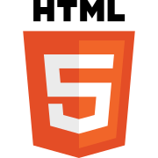

HTML

[HTML elements](https://en.wikipedia.org/wiki/HTML_element) are the building blocks of HTML pages. With HTML constructs, [images](https://en.wikipedia.org/wiki/HTML_element#Images_and_objects) and other objects such as [interactive forms](https://en.wikipedia.org/wiki/Fieldset) may be embedded into the rendered page. HTML provides a means to create [structured documents](https://en.wikipedia.org/wiki/Structured_document) by denoting structural [semantics](https://en.wikipedia.org/wiki/Semantics) for text such as headings, paragraphs, lists, [links](https://en.wikipedia.org/wiki/Hyperlink), quotes and other items. HTML elements are delineated by *tags*, written using [angle brackets](https://en.wikipedia.org/wiki/Bracket#Angle_brackets). Tags such as <**img** /> and <**input** /> directly introduce content into the page. Other tags such as <**p**> surround and provide information about document text and may include other tags as sub-elements. Browsers do not display the HTML tags, but use them to interpret the content of the page.

CSS

CSS is designed to enable the separation of presentation and content, including [layout](https://en.wikipedia.org/wiki/Page_layout), [colors](https://en.wikipedia.org/wiki/Color), and [fonts](https://en.wikipedia.org/wiki/Typeface).[[3]](https://en.wikipedia.org/wiki/Cascading_Style_Sheets#cite_note-3) This separation can improve content [accessibility](https://en.wikipedia.org/wiki/Accessibility), provide more flexibility and control in the specification of presentation characteristics, enable multiple [web pages](https://en.wikipedia.org/wiki/Web_page) to share formatting by specifying the relevant CSS in a separate .css file, and reduce complexity and repetition in the structural content.

JAVA SCRIPT

As a multi-paradigm language, JavaScript supports [event-driven](https://en.wikipedia.org/wiki/Event-driven_programming), [functional](https://en.wikipedia.org/wiki/Functional_programming), and [imperative](https://en.wikipedia.org/wiki/Imperative_programming) [programming styles](https://en.wikipedia.org/wiki/Programming_paradigm). It has [application programming interfaces](https://en.wikipedia.org/wiki/Application_programming_interface) (APIs) for working with text, dates, [regular expressions](https://en.wikipedia.org/wiki/Regular_expression), standard [data structures](https://en.wikipedia.org/wiki/Data_structure), and the [Document Object Model](https://en.wikipedia.org/wiki/Document_Object_Model) (DOM). However, the language itself does not include any [input/output](https://en.wikipedia.org/wiki/Input/output) (I/O), such as [networking](https://en.wikipedia.org/wiki/Computer_network), [storage](https://en.wikipedia.org/wiki/Data_storage), or [graphics](https://en.wikipedia.org/wiki/Computer_graphics) facilities, as the host environment (usually a web browser) provides those APIs.

SCREENSHOT OF WEBSITE

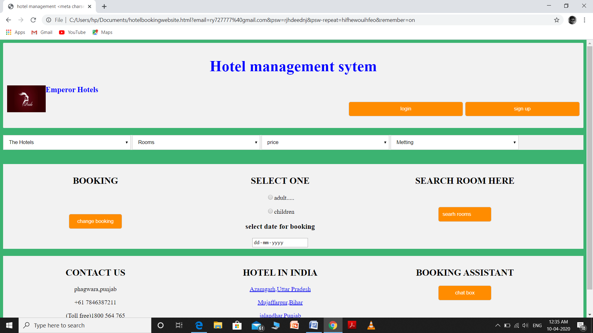

TEAM WORK

BY

Rahul yadav-

I design the all the fronted page like adding logo add all the button and use javascrpit to call the function to perform any action like for login page signup page.

Gaurav chaudhary-

I change the color and give the location of content using css.I used form tag to make a form type wher user can put their email id nad password.

Sneha sompali-

Firstly I learnt all the required concept to develops a website.Learnt to work onfronted then I wrote all the codes to develop this online hotel management system.